**Management & Planning Project**

* **Project idea and project planning:**

**Deliver a functional, aesthetically modern 80m² apartment design with 3D visualizations and animation video**

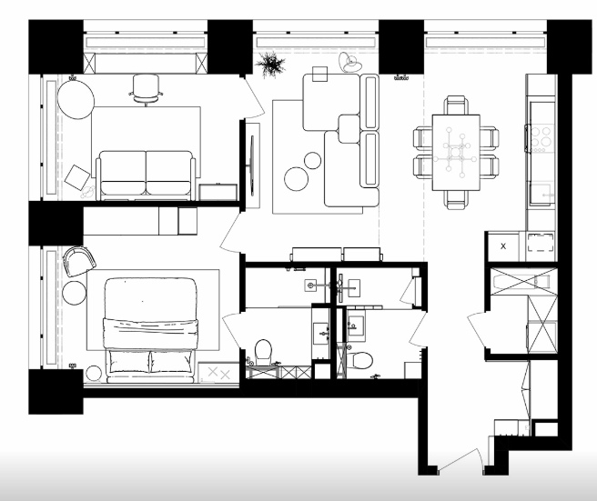

* **Style Inspiration: Modern** fusion (clean lines, wood accents, monochrome base).
* **Mood Board**:
  + Colors: White/gray walls, navy/terracotta accents.
  + Materials: Oak wood, matte ceramics, brushed metal.
  + Lighting: Geometric pendants, recessed LEDs.
* **Furniture**: Sleek, low-profile pieces (e.g., modular sofa, floating TV unit).
* **Lighting**:
  + Natural light via large windows + V-Ray Sun/Sky.
  + Task lighting (kitchen island pendants), ambient LEDs.
* **Materials**:
  + Matte kitchen cabinets, glossy bathroom tiles, textured rugs.
* **Project timeline**

|  |  |  |  |
| --- | --- | --- | --- |
| **Task** | **Description** | **Dates** | |
| **Idea,**  **Planning, and Task Division** | **Determining the apartment’s area, layout, and distributing spaces among project group members** | **8/2** | **10/2** |
| **Modeling** | **Preparing 3D models for each architectural space, including all elements** | **11/2** | **24/2** |
| **Lighting** | **Distributing appropriate lighting for each space** | **25/2** | **4/3** |
| **Materials** | **Applying pre-selected materials to project elements** | **5/3** | **12/3** |
| **Rendering** | **Final rendering (2–3 JPG files per space)** | **13/3** | **15/3** |
| **Postproduction** | **Final adjustments using Photoshop** | **17/3** |  |
| **Animation** | **Animation work using Adobe Premiere and Compile and edit the video animation for the whole project and extract the mp4 file** | **18/3** | **4/4** |
| **Project Compilation** | **Compiling all project elements** | **5/4** | **7/4** |

* **Team & Individual Tasks:**

|  |  |  |
| --- | --- | --- |
| **Bath room** | **Reham Barakat** |  |
| **Bed room** | **Shrief Dyaa Aldean Abd Alhy** |
| **Office room** | **Gerges Romany Sedky** |
| **Living room** | **Jolie Magdy Mounir** |
| **Dining room-kitchen** | **Abdelrahman Ahmed Eid** |
| **Entrance** | **Ann Tawfik** |

* **Tools:**
* 3Ds Max, for modeling,
* V-Ray for lighting texturing, and rendering
* Photoshop for postproduction.
* Adobe Premiere for animation video.
* Excel/Google Sheets for schedules.